**MATHS ASSIGNMENT - 3**

**Question No. 1(ILO 4)**

Approximate the solution to the following heat equation up to second time

level using Schmidth method with and

subjected to

**Solution 1:** Given**,**

Also,

From initial Condition,

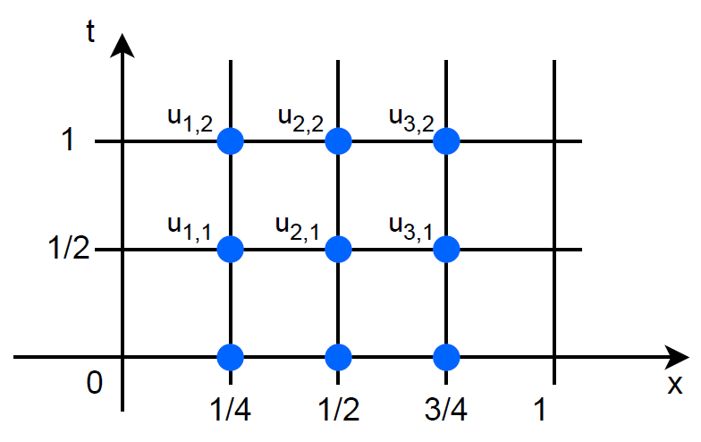

According to Schimidth Method,

For first Time level :

For Second time level :

**Question No. 2(ILO 4)**

A random sample of income from the users of a telecom company showed

|  |  |  |  |  |  |  |  |
| --- | --- | --- | --- | --- | --- | --- | --- |
| Number of users(x) (in millions) | 26 | 29 | 32 | 34 | 36 | 37 | 40 |
| Income(y) (in billions) | 48 | 68 | 66 | 69 | 76 | 67 | 84 |

(a). Obtain the correlation coefficient and comment on the type of relation between the variables.

(b). Determine the regression line between the variables.

**Solution 2:**

|  |  |  |  |  |
| --- | --- | --- | --- | --- |
|  |  |  |  |  |
| 26 | 48 | 1248 | 676 | 2304 |
| 29 | 68 | 1972 | 841 | 4624 |
| 32 | 66 | 2112 | 1024 | 4356 |
| 34 | 69 | 2346 | 1156 | 4761 |
| 36 | 76 | 2736 | 1296 | 5776 |
| 37 | 67 | 2479 | 1369 | 4489 |
| 40 | 84 | 3360 | 1600 | 7056 |

Substituting the data in below equation:

Therefore, there is a string correlation between the two variables.

Substituting the data,

here,

Substitution in values of a and b in equation, we get

Hence, this is the required line equation.

**Question No. 3(ILO 5)**

Two groups are competing for the position on the board of directors of a corporation. The probabilities that the first and the second groups will win are 0.6 and 0.4 respectively. Further, if the first group wins, the probability of introducing a new product is 0.7 and the corresponding probability is 0.3 if the second group wins. Find the probability that the new product introduced was by the second group.

**Solution 3:**

Given data:

Let A and B be two groups.

Let C be the event of introducing new product new product introduced after A wins,

New product introduced after B wins,

Since both are independent events applying total probability,

Therefore, the probability that the new product introduced was by the second group is .